Oak Hill CE Primary School
Newsletter 3rd May 2024
Jesus said, ‘I have come that you may have life in all its fullness’ (John 10:10)
Active breaks
As part of our drive to ensure that our children have varied opportunities to enjoy and be active during break times, a trim trail has been installed on the school grounds. This has been welcomed enthusiastically by the children and we look forward to many years of use. A huge thank you to FOOHS for their generosity in funding this resource!
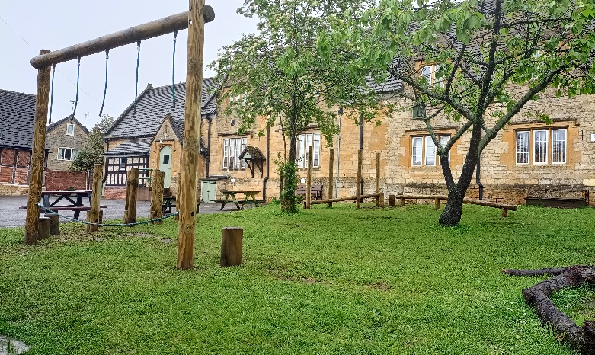 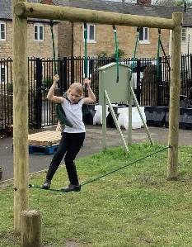

May is National Walking Month
National Walking Month - now mornings and evenings are lighter for longer, it’s the perfect time to get out and active. Walking has a host of health benefits that can motivate the whole family to introduce walking into your daily lives.
On Tuesday 21st May, weather permitting; KS2 will be going on a walk in the local area. This walk was great fun last year and all the children had a wonderful time. We take a circular route from Alderton through Dumbleton (letter to follow).
Church services for this Sunday 28th April
9.00am - Gt Washbourne - HC for the Easter Season
10.30am - Dumbleton - HC for the Easter Season

Our half termly Christian value is perseverance: to go on doing something even though it is difficult

Attendance update
Attendance this week has been 96.49% but with a great effort from Reception children maintaining 100% again!
Our target this year remains a minimum of 96% across the whole school and our year to date is now at 93.48%.
Please check the NHS guide “Is my child too ill for school”: https://www.nhs.uk/live-well/is-my-child-too-ill-for-school/


House Points
Ashdown 81
Dean 95
Sherwood 72
Rowan class star of the week
Rory: persevering with your handwriting and presentation
Elm class star of the week
Miles: working hard to complete more work to an improved standard.
Redwood class stars of the week
Oz for an amazing start to his Oak Hill journey.
Henry for a fantastic Minoan civilisation report.
Diary dates (subject to change):
MAY
8th Nature In Art trip - whole school
10th Swimming Y5&6
17th Swimming Y5&6
21st KS2 Walk
22nd Move More tag rugby festival
24th Swimming Y5&6
JUNE
6th Science festival - whole school - letter to follow
7th Swimming Y5&6
13th Olympic & PE workshops - whole school - details to follow
14th Swimming Y5&6
21st Swimming Y5&6
28th Swimming Y5&6
JULY
5th Swimming Y5&6 - replacement session
12th Sports event followed by Olympic fair by FOOHS
15th Reserve date for sports event

