Growing and Changing – part of our Personal Social Health and Economic Education (PSHE)
Year 2
What your child has been learing about:

This half term's PSHE topic 'Growing and Changing' incorporated Relationships and Health Education (RHE) and has been designed to cover key skills, attitudes and values children need to explore in order to develop healthy relationships with their peers. Children have also learnt how to keep themselves safe and how to ask for help when they need it.
Year 2 topics build on and reinforce the themes of the previous years. New content has covered the process of growing from young to old and how people’s needs change. We’ve explored the opportunities and responsibilities that increasing independence can bring, recognising that children share a responsibility for keeping themselves and others safe.
Your child has been taught to recognise a range of feelings that are associated with losing (and being reunited with) a person they are close to. Revisiting the learning in EYFS and Year 1, children are able to identify which parts of our body are private and know the correct vocabulary for these private parts.
Children have also learnt that parts of their genitals (sperm found in testicles, and eggs found in ovaries inside women’s bodies) help to make babies when we are older. We’ve worked on the theme of consent and privacy, understanding what privacy means, including private information about somebody that is not to share with others, knowing that you are not allowed to touch someone’s private belongings without their permission, and not to touch the private parts of others.

Vocabulary your child learnt:

emotions, unique, penis, testicles, ovaries, vulva, nipples, genitals, privates, consent, permission, risk, hazard, accident, emergency

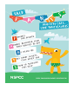
NSPCC PANTS Rule

Questions your child may ask at this age:
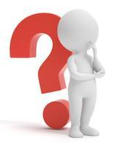
- How do babies grow?
- When you were little, did you know what you wanted to be as a grown up?
- Do you have a vulva or a penis?
- What makes us grow?
- Why are private parts private?
- Who can I go to for help or advice if I need it? Can you help me think about who my trusted adults are?
- How are babies made?
- What will I be like when I get older?
- What happens when you get old?
- Can you help me to remember the 5 rules of our NSPCC PANTS lesson? Privates are private; Always remember your body belongs to you; NO means NO; Talk about secrets that upset you; Speak up, someone can help.


Resources for parents: SCARF Growing and Changing Parents Page
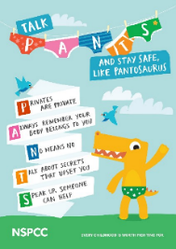



Healthy relationships | NSPCC Healthy Relationships 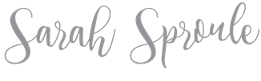
How to talk to your kids about everything RSE related
The Underwear Rule
NSPCC

Age 6-10 | Outspoken Sex Ed Resource for Parents

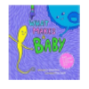
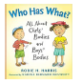
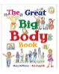
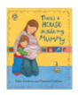
Books to support learning:

There’s a House Inside What Makes a Baby The Great Big Who Has What?
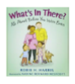
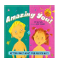
My Mummy Body Book

Getting Smart about Before You
Your Private Parts Were Born

